

# EXPERIMENT - 9

**Aim:** To Understand Continuous monitoring and Installation and configuration of Nagios Core, Nagios Plugins and NRPE (Nagios Remote Plugin Executor) on Linux Machine.

# Theory:

**Nagios** is an event monitoring system that offers monitoring and alerting services for servers, switches, applications and services. It alerts users when things go wrong and alerts them a second time when the problem has been resolved.

Some key features of Nagios Core:

# Visibility:

Enhance user access to relevant information with a centralized view of the monitoring data and third-party insights that are most critical to you.

# Customizability:

Give users and team members the flexibility to tailor layout, design, and preferences on a per-user basis with a customizable GUI.

# Multi-Tenant Capabilities and Ease of Use:

Simplify administration with advanced user management to efficiently manage user accounts and ensure clients only see the infrastructure components they’re authorized for.

**Nagios NRPE:** (Nagios Remote Plugin Executor) is an agent used by Nagios XI for communicating with remote hosts. It allows you to run Nagios plugins on remote machines, enabling the monitoring of remote machine metrics such as disk usage, CPU load, and more.

**Nagios Plugins** are **external programs or scripts that run from the command line to check the status of hosts and services on a network**. They are an essential part of the Nagios monitoring system, as they provide the necessary information for Nagios Core to determine the current status of monitored resources.

# STEPS to install Nagios Core:

1. Install dependencies

*~$ sudo apt install build-essential apache2 php libapache2-mod-php php-gd libgd-dev unzip automake*

1. Download the latest version archive file.

*~$wgethttps: /github.com/NagiosEnterprises/nagioscore/archive/nagios-4.4.6.tar.gz*

*~$ tar xzf nagios-4.4.6.tar.gz*

*~$ cd nagioscore-nagios-4.4.6/*

1. Configure it.

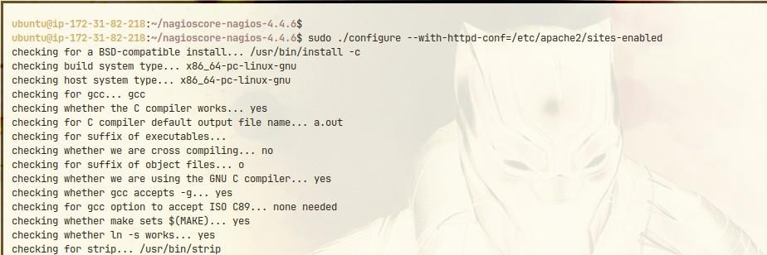

1. Start Compilation.

*~$ sudo make all*

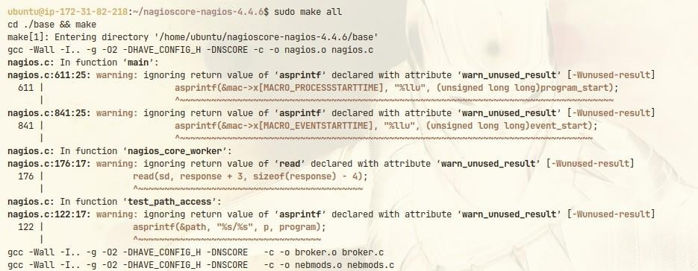

1. Add user of nagios

*~$ sudo useradd nagios*

*~$ sudo usermod -a -G nagios www-data*

1. Make install

*~$ sudo make install*

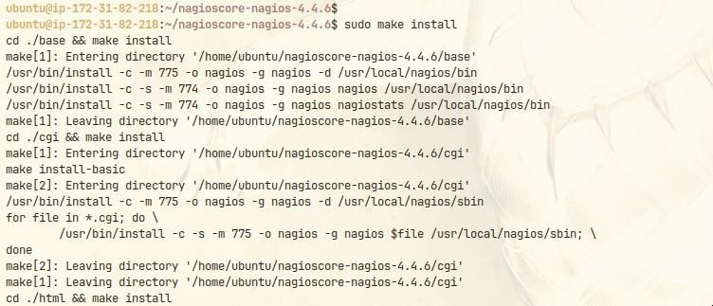

1. compile other required modules

*~$ sudo make install-daemoninit install-commandmode install-config install-webconf*

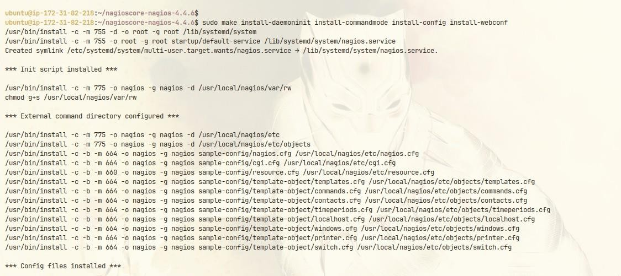

# STEPS to install Nagios Plugin:

1. Now compile and install Nagios Plugins

*~$wgethttps:/github.com/nagios-plugins/nagios-plugins/archive/release-2.3.3.tar.gz*

*~$ tar xzf release-2.3.3.tar.gz*

*~$ cd nagios-plugins-release-2.3.3/*

1. Setup, Configure, compile and install.

*~$ sudo ./tools/setup*

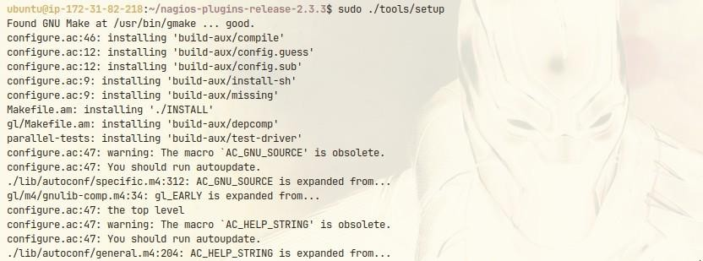

*~$ sudo ./configure*

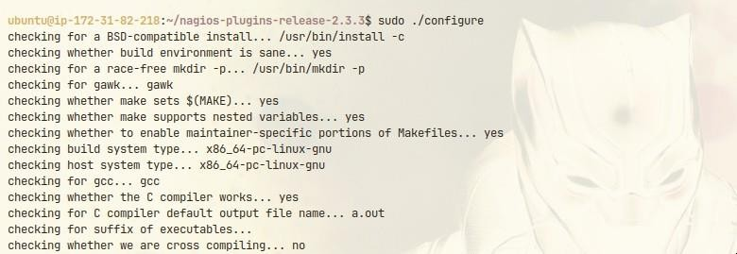

*~$ sudo make*

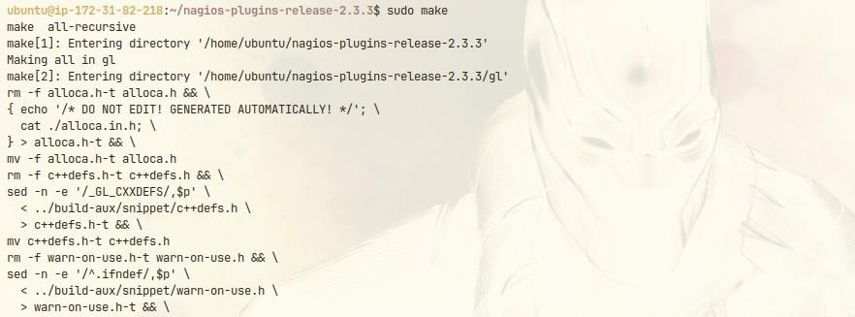

*~$ sudo make install*



# Now install NRPE

*~$ sudo apt install nagios-nrpe-server nagios-nrpe-plugin*

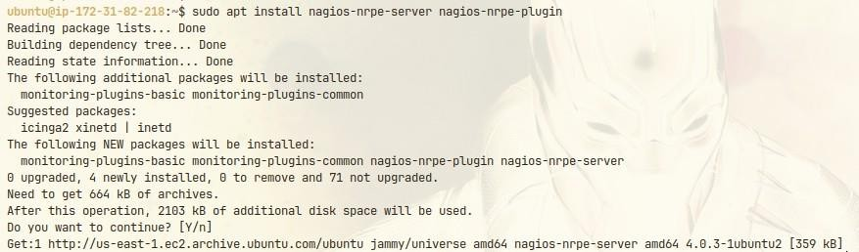

# Now, it’s time to configure.

*~$ sudo nano /etc/nagios/nrpe.cfg*

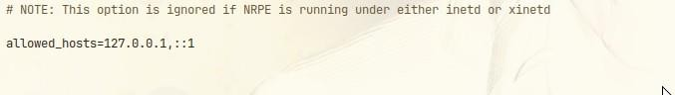

# Setup apache password.

*~$ sudo htpasswd -c /usr/local/nagios/etc/htpasswd.users nagiosadmin*

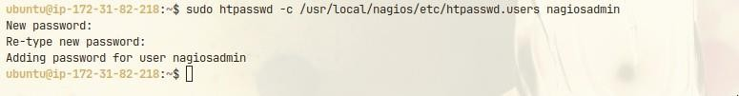

# Enable & Start Nagios Service.

*~$ sudo systemctl enable -now nagios*

*~$ sudo systemctl enable -now nagios-nrpe-server*

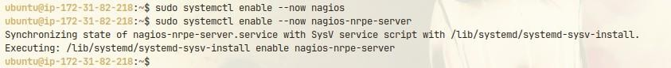

You can now access it on your server’s IP at ‘/nagios’. Enter your username & password.

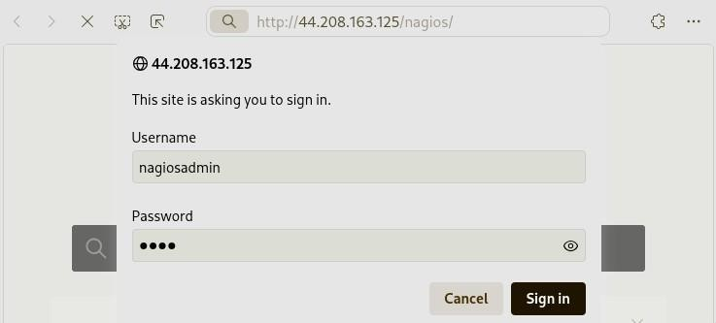

And, After logging in you will the home page of Nagios.

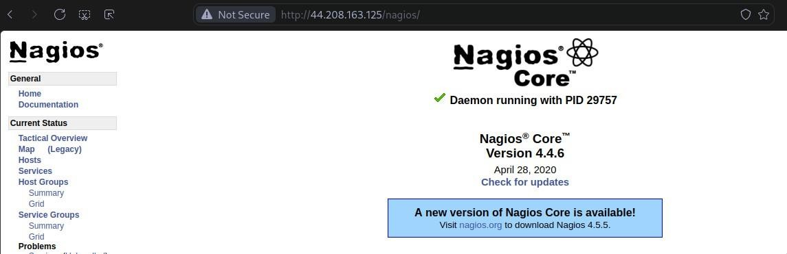

**Conclusion:** Thus, we have successfully Understood Continuous monitoring and Installation and configuration of Nagios Core, Nagios Plugins and NRPE (Nagios Remote Plugin Executor) on Linux Machine.